A PROJECT REPORT
ON

EFFICIENT FPGA DEPLOYMENT OF AN INT16 QUANTIZED NEURAL NETWORK (QNN) FOR CALIFORNIA HOUSE PRICE PREDICTION USING TANG NANO 9K BOARD

submitted in partial fulfilment of the requirement for the award of the degree of
Bachelor of Technology
In
Electronics Engineering

By

RISHABH CHAUBEY (2201100300043)
ANUBHAV SINGH (2201100300013)
ANUJ KUMAR (2201100300014)

Under the Supervision of

DR. YATINDRA GAURAV
Assistant Professor & Head of Department

MR. SANJEEV GUPTA
Project Supervisor, Department of Electronics Engineering

Department of Electronics Engineering
INSTITUTE OF ENGINEERING AND RURAL TECHNOLOGY
PRAYAGRAJ, UTTAR PRADESH — 211002
Dr. A.P.J. Abdul Kalam Technical University, Lucknow

2022 – 2026

DECLARATION

We, Rishabh Chaubey, Anubhav Singh, and Anuj Kumar, solemnly declare that the project report titled "EFFICIENT FPGA DEPLOYMENT OF AN INT16 QUANTIZED NEURAL NETWORK (QNN) FOR CALIFORNIA HOUSE PRICE PREDICTION USING TANG NANO 9K BOARD" is our own work carried out during the course of our study under the supervision of Dr. Yatindra Gaurav (Assistant Professor & Head of Department) and Mr. Sanjeev Gupta (Project Supervisor), Department of Electronics Engineering, Institute of Engineering and Rural Technology, Prayagraj, Uttar Pradesh, India.

We assert that the statements made and conclusions drawn are an outcome of our project work. We further certify that:

- We have adhered to all principles of academic honesty and integrity and have not misrepresented or fabricated or falsified any idea/data/fact/source in our submission.
- The work contained in this report is original and has been done under the joint supervision of Dr. Yatindra Gaurav and Mr. Sanjeev Gupta; where others' ideas or words have been included, we have adequately cited and referenced the original sources.
- The work has not been submitted to any other Institution for any other degree/diploma/certificate in this university or any other University of India or abroad.
- Wherever we have used materials (text, data, theoretical analysis/equations, codes, program, figures, tables, pictures, etc.) from other sources, we have given due credit to them in the report and have also provided details in the references.

RISHABH CHAUBEY (2201100300043) ANUBHAV SINGH (2201100300013)
ANUJ KUMAR (2201100300014)

Date:
Place: PRAYAGRAJ

CERTIFICATE

This is to certify that the project-report titled, "EFFICIENT FPGA DEPLOYMENT OF AN INT16 QUANTIZED NEURAL NETWORK (QNN) FOR CALIFORNIA HOUSE PRICE PREDICTION USING TANG NANO 9K BOARD" is Bonafide research/project work of RISHABH CHAUBEY (2201100300043), ANUBHAV SINGH (2201100300013), ANUJ KUMAR (2201100300014) carried out under our joint guidance and supervision.

We also confirm that the work presented is original, novel and has been carried out by Rishabh, Anubhav, and Anuj during their B.Tech Programme. The results and conclusions drawn in this project-report are based on their own research/project and have not been submitted elsewhere for any degree.

DATE:

Dr. Yatindra Gaurav Mr. Sanjeev Gupta
Assistant Professor & H.O.D. Project Supervisor
Department of Electronics Engineering
Institute of Engineering and Rural Technology, Prayagraj

APPROVAL SHEET

This project/research entitled "EFFICIENT FPGA DEPLOYMENT OF AN INT16 QUANTIZED NEURAL NETWORK (QNN) FOR CALIFORNIA HOUSE PRICE PREDICTION USING TANG NANO 9K BOARD" by RISHABH CHAUBEY (2201100300043), ANUBHAV SINGH (2201100300013), ANUJ KUMAR (2201100300014) is approved for the degree of Bachelor of Technology in Electronics Engineering.

Examiner

Supervisor: Mr. Sanjeev Gupta

Head of Department: Dr. Yatindra Gaurav

Date:
Place: Prayagraj, Uttar Pradesh

ACKNOWLEDGEMENT

With deep gratitude and heartfelt respect, we take this opportunity to express our sincere thanks to all those who contributed to the successful completion of this project.

First and foremost, we extend our deepest appreciation to Dr. Vimal Mishra, Director of IERT Prayagraj, for providing the academic environment and constant encouragement throughout our academic journey.

We are profoundly grateful to Dr. Yatindra Gaurav, Head of Department, for his invaluable guidance, expert insights, and persistent support. His expertise in VLSI Design and neural network deployment on FPGA was truly a gamechanger. His mentorship has been instrumental in shaping this project into a research-worthy work. His 'Reach-Anytime' nature and eagerness to help students develop valuable skills has helped us grow both technically and intellectually.

We are equally indebted to Mr. Sanjeev Gupta, our dedicated Project Supervisor, whose hands-on guidance throughout every stage of implementation was invaluable. His practical expertise in digital design and FPGA programming, his clarity in resolving implementation doubts, and his consistent encouragement during the many challenging phases of this project have been foundational to its successful completion. This project would not have reached its final form without his direct and sustained mentorship.

We are deeply grateful to Dr. Alka Verma, Assistant Professor, for her exceptional guidance and support throughout our entire academic journey. Her expertise, approachability, and clear communication were instrumental for us. She always showed the way when we were in doubt.

We also thank Dr. C.P. Singh, Senior Faculty Member, Electronics Engineering Department, for his valuable suggestions, critical reviews, and encouragement at various stages of the project. His constructive feedback helped improve the quality of the work significantly.

A very special note of thanks goes to our parents for their unconditional support, patience, and faith in our abilities. Their emotional strength and motivation have been the foundation of all our efforts.

Lastly, we are thankful for every form of critique, feedback, and constructive suggestion — be it from faculty, peers, or reviewers — which helped refine this project into its final form.

RISHABH CHAUBEY (2201100300043) ANUBHAV SINGH (2201100300013)
ANUJ KUMAR (2201100300014)

ABSTRACT

This paper presents an INT16 Quantized Neural Network (QNN) model for California housing price prediction, implemented on the Tang Nano 9K FPGA board using Verilog HDL. The dataset was preprocessed using MinMaxScaler normalization, followed by training a Multi-Layer Perceptron (MLP) deep neural network with ReLU activations. The trained model was converted to INT16 fixed-point representation and deployed on FPGA using VS Code tools and Gowin synthesis flow.

The design demonstrates the feasibility of deploying a regression neural network on an FPGA with optimized LUT, DFF, and bounded IOB utilization. A complete serial communication pipeline consisting of a UART Receiver (uart_rx.v), UART Transmitter (uart_tx.v), and Baud Rate Generator (baud.v) facilitates data transfer between the host PC and the FPGA. The inference engine employs a pipelined Finite State Machine (FSM) in Moore configuration, with all quantized weights and biases stored in Block RAM (BRAM) initialized from a .mem file.

The achieved software metrics are R² Score ≈ 0.70, RMSE ≈ 60,000, and MAPE ≈ 24%. The FPGA implementation achieved 2% LUT usage, 4% DFF, 1% bounded IOB, and consumed approximately 70.51 mW of total power — highlighting its efficiency for real-time embedded inference. All modules were verified using a comprehensive 7-test-case Verilog testbench.

Keywords: QNN (INT16), Tang Nano 9K FPGA, California Housing Dataset, UART, BRAM, Verilog, MinMaxScaler, MLP Regression, Fixed-Point Arithmetic, FSM Moore, Dr. Yatindra Gaurav, Mr. Sanjeev Gupta.

LIST OF PUBLICATIONS

- "Normalised MLP Regression and ONNX-Grounded using MINIST California Housing Price Prediction on FPGA" — Conference Paper, IERT Prayagraj, 2025. (Under guidance of Dr. Yatindra Gaurav & Mr. Sanjeev Gupta)
- "Efficient FPGA Deployment of INT16 Quantized Neural Network for Regression Tasks" — Under review, AUT Journal, 2025.

TABLE OF CONTENTS

CHAPTER NO. | TITLE | PAGE NO.
 | DECLARATION | ii
 | CERTIFICATE | iii
 | APPROVAL SHEET | iv
 | ACKNOWLEDGEMENT | v
 | ABSTRACT | vi
 | LIST OF PUBLICATIONS | vii
 | LIST OF FIGURES | viii
 | LIST OF TABLES | ix
 | LIST OF SYMBOLS | x
1. | INTRODUCTION | 1
1.1 | Background and Motivation | 1
1.2 | Problem Statement | 2
1.3 | Objectives | 3
1.4 | Scope of Work | 3
2. | LITERATURE SURVEY | 5
3. | SYSTEM DESIGN AND METHODOLOGY | 8
3.1 | Dataset and Feature Selection | 8
3.2 | Data Preprocessing | 9
3.3 | Neural Network Architecture | 9
3.4 | Quantization to INT16 | 10
3.5 | Memory Generation for FPGA | 11
3.6 | Hardware Mapping Strategy | 11
4. | CIRCUIT DESIGN AND FPGA IMPLEMENTATION | 13
4.1 | Full System Circuit Diagram and | 13
4.2 | BRAM Module Circuit | 15
4.3 | Baud Rate Generator Circuit and | 17
4.4 | UART Receiver Circuit and | 19
4.5 | UART Transmitter Circuit and | 21
4.6 | Top-Level Integration | 23
4.7 | FSM (Moore Machine) Design | 24
5. | TESTBENCH AND VERIFICATION | 26
6. | RESULTS AND PERFORMANCE ANALYSIS | 28
7. | CONCLUSION AND FUTURE WORK | 32
8. | REFERENCES | 34

LIST OF FIGURES

FIGURE NO. | DESCRIPTION OF FIGURE | PAGE NO.
Fig. 3.1 | Block Diagram — Overall System Pipeline | 8
Fig. 3.2 | MLP Architecture (1-16-8-1) | 10
Fig. 4.1 | Full System Circuit Diagram (Top Module) | 13
Fig. 4.2 | BRAM Module (bram_all.v) Circuit Diagram and Schematic Diagram | 15
Fig. 4.3 | Baud Rate Generator (baud.v) Circuit Diagram and Schematic Diagram | 17
Fig. 4.4 | UART Receiver (uart_rx.v) Circuit Diagram and Schematic Diagram | 19
Fig. 4.5 | UART Transmitter (uart_tx.v) Circuit Diagram and Schematic Diagram | 21
Fig. 4.6 | Top-Level Module Interconnect Diagram and Schematic Diagram | 23
Fig. 4.7 | FSM (Moore Machine) State Transition Diagram | 24
Fig. 5.1 | Testbench Simulation Waveform Flow | 26
Fig. 6.1 | Actual vs Predicted Values Scatter Plot | 29
Fig. 6.2 | RMSE Evaluation Graph | 29
Fig. 6.3 | R² Score Graph | 30
Fig. 6.4 | MAPE Graph | 30
Fig. 6.5 | FPGA Resource Utilization Chart | 31

LIST OF TABLES

TABLE NO. | DESCRIPTION OF TABLE | PAGE NO.
Table 3.1 | MLP Neural Network Architecture Summary | 9
Table 3.2 | INT16 Quantization Parameters | 10
Table 4.1 | UART Communication Protocol Parameters | 15
Table 4.2 | BRAM Port and Configuration Summary | 16
Table 4.3 | Baud Rate Generator Parameters | 18
Table 4.4 | FSM State Encoding and Transitions | 24
Table 5.1 | Testbench Test Cases Summary | 27
Table 6.1 | Software Model Evaluation Metrics | 28
Table 6.2 | CPU vs FPGA Performance Comparison | 29
Table 6.3 | FPGA Resource Utilization Summary | 31
Table 6.4 | Power Consumption Breakdown | 31

LIST OF SYMBOLS AND ABBREVIATIONS

Symbol / Abbreviation | Full Form / Meaning
FPGA | Field Programmable Gate Array
QNN | Quantized Neural Network
MLP | Multi-Layer Perceptron
UART | Universal Asynchronous Receiver/Transmitter
BRAM | Block Random Access Memory
FSM | Finite State Machine
ReLU | Rectified Linear Unit
INT16 | 16-bit Signed Integer Fixed-Point
MAC | Multiply-Accumulate
LUT | Look-Up Table
DFF | D Flip-Flop
IOB | Input/Output Block
RMSE | Root Mean Square Error
MAPE | Mean Absolute Percentage Error
R² | Coefficient of Determination
HDL | Hardware Description Language
TX | Transmit
RX | Receive
W1,W2,W3 | Weight matrices (Layer 1, 2, Output)
B1,B2,B3 | Bias vectors (Layer 1, 2, Output)
DIV | Baud divisor = 234 (27 MHz / 115200 baud)
HALF | Half-baud offset = 117 (center-bit sampling)
FULL | Full-baud period = 234 clock cycles

CHAPTER 1
INTRODUCTION

1.1 Background and Motivation
Deep learning techniques have become increasingly important for solving regression problems in domains such as finance, real estate, image processing, and engineering analytics. Among these, house price prediction is widely studied due to its practical significance and the complex data relationships it exhibits. Traditional software-based implementations of deep learning models provide high accuracy but suffer from high computational cost and power consumption, making them less suitable for embedded and edge computing systems.

Field Programmable Gate Arrays (FPGAs) have emerged as a promising platform for accelerating machine learning and deep learning models due to their inherent parallel processing capability, low latency, and superior energy efficiency. Unlike CPUs and GPUs that operate on Von Neumann architecture, FPGAs offer customizable data paths tailored specifically to the algorithm, resulting in significant throughput improvements. The Tang Nano 9K, a compact and low-cost FPGA board based on the Gowin GW1NR-9 chip, provides an ideal platform for embedded AI inference.

However, deploying a neural network on an FPGA is challenging due to limited hardware resources and the absence of a native floating-point unit in many low-cost FPGA devices. To overcome this limitation, this project implements a Quantized Neural Network (QNN) operating in INT16 fixed-point arithmetic, where all parameters are represented as 16-bit signed integers. This work is carried out under the joint supervision of Dr. Yatindra Gaurav (HOD) and Mr. Sanjeev Gupta (Project Supervisor), Department of Electronics Engineering, IERT Prayagraj.

1.2 Problem Statement
The California Housing dataset offers a benchmark regression task where the median income of a district (MedInc) predicts the median house value. The challenge lies in deploying an accurate and efficient inference engine on a resource-constrained FPGA device. Key challenges include:
- Conversion of floating-point neural network weights to INT16 fixed-point without significant accuracy loss.
- Storage and retrieval of quantized parameters from Block RAM (BRAM) initialized via .mem files.
- Design of a complete serial communication interface using UART for host-to-FPGA and FPGA-to-host data transfer at 115200 baud over a 27 MHz clock.
- Implementation of a pipelined inference engine using a Moore-type FSM in synthesizable Verilog HDL.
- Functional verification using a comprehensive testbench covering 7 test cases including edge conditions.

1.3 Objectives
- To train a simplified MLP regression model using a single input feature (MedInc) on the California Housing dataset using scikit-learn and Python.
- To quantize the trained model parameters to INT16 fixed-point representation using the formula q = round(x × 32767).
- To implement the quantized inference engine in Verilog HDL on the Tang Nano 9K FPGA.
- To design and integrate UART communication modules: UART RX (uart_rx.v), UART TX (uart_tx.v), and Baud Rate Generator (baud.v).
- To store weight and bias matrices in BRAM using .mem initialization files loaded via $readmemh.
- To verify correctness using a simulation testbench with 7 comprehensive test cases.
- To compare FPGA implementation results with CPU-based software execution.

1.4 Scope of Work
- Data acquisition and preprocessing using MinMaxScaler normalization in Python.
- Training an MLP model with architecture 1–16–8–1 using scikit-learn MLPRegressor.
- Exporting quantized weights and biases to qnn.mem for BRAM initialization.
- Writing synthesizable Verilog modules: baud.v, uart_rx.v, uart_tx.v, bram_all.v, top.v.
- Developing a Verilog testbench tb_top.v with UART send/receive tasks and FSM monitoring.
- Analysing FPGA resource utilization and power using Gowin EDA synthesis reports.

CHAPTER 2
LITERATURE SURVEY

The deployment of neural networks on FPGAs has been an active research area for over a decade. This chapter reviews key prior works relevant to FPGA-based MLP accelerators, quantized neural networks, UART communication interfaces, and the Tang Nano 9K platform.

2.1 FPGA-Based MLP Accelerators
Kokkinis and Siozios (2025) presented a fast resource estimation methodology for FPGA-based MLP accelerators targeting TinyML applications. Their work demonstrated that even small FPGAs can efficiently host quantized neural networks when the model architecture is simplified and arithmetic precision is reduced to INT8 or INT16. They showed that INT16 representations offer significant area savings over FP32 while maintaining acceptable accuracy for regression tasks — directly motivating the INT16 approach in this project.

Bahoura and Park (2011) implemented a high-speed MLP neural network on FPGA using the ICECS framework. Their work focused on pipelined MAC operations and demonstrated that FPGAs achieve inference latency orders of magnitude lower than CPU-based implementations for the same network size. Their use of distributed arithmetic and LUT-based multipliers to reduce resource consumption informs the MAC architecture of this project.

2.2 House Price Prediction with Machine Learning
Mora-Garcia et al. (2022) conducted a comprehensive survey of house price prediction using machine learning techniques. They evaluated MLP-based approaches with proper feature engineering and normalization, showing R² scores above 0.70 on standardized datasets. Their finding that median income is the single most predictive feature for California house prices directly motivated the single-feature approach in this project.

The California Housing dataset from the 1990 US Census has been widely used as a regression benchmark. Studies confirm that MedInc alone explains approximately 70% of the variance in house prices, making it a natural choice for a simplified hardware implementation targeting embedded inference.

2.3 Quantization Strategies for FPGA
A Survey on FPGA-Based Accelerators for Machine Learning models (2024) comprehensively reviewed quantization strategies. The survey found that INT16 quantization strikes an optimal balance between numerical precision and hardware resource consumption for regression tasks where output values span a wide dynamic range. The uniform symmetric quantization formula q = round(x × 32767) preserves parameter sign and maintains arithmetic commutativity, which is crucial for hardware implementation.

2.4 UART-Based FPGA Communication
UART remains one of the most widely used serial communication protocols for FPGA-to-PC data transfer due to its simplicity and ubiquitous hardware support. At 27 MHz clock and 115200 baud, the baud divisor is DIV = round(27,000,000 / 115,200) = 234, producing a timing accuracy of ±0.16% — well within the ±5% UART tolerance. Center-bit sampling (sampling at HALF = DIV/2 after start-bit detection) maximizes noise immunity, as exploited in the uart_rx.v module of this project.

2.5 Tang Nano 9K FPGA Platform
The Tang Nano 9K is a low-cost FPGA development board based on the Gowin GW1NR-9 chip, featuring 8640 LUT4s, 6480 Flip-Flops, 26 BRAM tiles (18 Kb each), and an onboard 27 MHz oscillator. Its USB-C programming interface and Gowin EDA tool support make it ideal for embedded AI inference projects. Previous works have confirmed its suitability for deploying small convolutional and fully-connected networks.

CHAPTER 3
SYSTEM DESIGN AND METHODOLOGY

This chapter describes the complete workflow of the proposed system from data preprocessing through neural network training, quantization, and FPGA deployment — as designed under the guidance of Dr. Yatindra Gaurav and Mr. Sanjeev Gupta.

3.1 Dataset and Feature Selection
The California Housing dataset from the MINIST collection is used for this regression task, containing 20,640 samples with 8 input features. To simplify hardware implementation and reduce FPGA resource consumption, only one feature is selected: MedInc (Median Income). This feature shows the highest Pearson correlation coefficient with the target variable (r ≈ 0.69) and reduces the number of Layer 1 multipliers from 8 to 1, significantly lowering LUT and BRAM usage.

3.2 Data Preprocessing
The selected feature is normalized using Min-Max Scaling (MinMaxScaler from scikit-learn) to map input values to [0, 1], ensuring faster convergence during training:
X' = (X - X_MIN) / (X_MAX - X_MIN)
Where X_MIN = 0.4999 and X_MAX = 15.0001 (training set extremes). The same scaler parameters are applied to test data to prevent leakage. After normalization, input values in [0, 1] are multiplied by 32767 to produce INT16 values in [0, 32767] for FPGA inference.

Fig. 3.1: Block Diagram — Overall System Pipeline
A Multi-Layer Perceptron (MLP) regression model with the following architecture is used:

Layer | Type | Neurons | Activation | Parameters
Input | Input Layer | 1 | None | 0
Hidden 1 | Fully Connected | 16 | ReLU | 16W + 16B = 32
Hidden 2 | Fully Connected | 8 | ReLU | 128W + 8B = 136
Output | Fully Connected | 1 | None (Linear) | 8W + 1B = 9
Total | — | — | — | 177 parameters
Table 3.1: MLP Neural Network Architecture Summary

The ReLU activation function is used in hidden layers:
f(x) = max(0, x)
In INT16 hardware, ReLU is implemented as a simple sign-bit check — if the value is negative (bit[15]=1), output 0; otherwise pass through unchanged. This requires no multipliers or adders, only a single 2-to-1 multiplexer per neuron.
Fig. 3.2: MLP Architecture (1-16-8-1) — Synthesized Circuit Schematic (Vivado/VS Code)

3.4 Quantization to INT16
All floating-point weights and biases are quantized to 16-bit signed integers:
q = round(x * 32767)

Parameter | FP32 Range | INT16 Range | Scale Factor
W1 (16×1) | [-2.1, +1.8] | [-32767, +32767] | 32767
B1 (16) | [-0.5, +0.9] | [-16384, +29490] | 32767
W2 (8×16) | [-1.5, +1.3] | [-32767, +32767] | 32767
B2 (8) | [-0.8, +0.7] | [-26214, +22938] | 32767
W3 (1×8) | [-1.2, +2.0] | [-32767, +32767] | 32767
B3 (1) | [-0.3] | [-9830] | 32767
Table 3.2: INT16 Quantization Parameters

3.5 Memory Generation for FPGA
Quantized weights and biases are written to hexadecimal .mem files loaded into BRAM at power-on via $readmemh. The combined qnn.mem file contains all 177 INT16 parameters (354 bytes) in address order: W1[0..15], B1[0..15], W2[0..127], B2[0..7], W3[0..7], B3[0].

3.6 Hardware Mapping Strategy
The inference pipeline follows a feedforward architecture controlled by the Moore FSM:
- UART RX receives data byte → stored in input_medinc[15:0].
- UART RX receives trigger 0x01 → start_trigger pulse.
- FSM: IDLE → LOAD (reset counter) → COMP (parallel MAC all layers) → LATCH (capture result) → SEND (3-byte TX) → IDLE.
- All arithmetic is INT16 signed; ReLU applied as sign-bit check.
- BRAM provides weight and bias data synchronously (1-cycle read latency).

CHAPTER 4
CIRCUIT DESIGN AND FPGA IMPLEMENTATION

This chapter presents detailed circuit diagrams and implementation descriptions for each module of the FPGA inference system. All diagrams were produced from the actual Verilog source code (top.v, bram_all.v, baud.v, uart_rx.v, uart_tx.v).

4.1 Full System Circuit Diagram
The complete FPGA inference system integrates four functional blocks: the UART Communication Block (baud_gen, uart_rx, uart_tx), the Control Block (FSM Moore Machine), the Computation Block (MAC, ReLU, Layer-wise propagation), and the Memory Block (BRAM). The following diagram shows all signal connections:

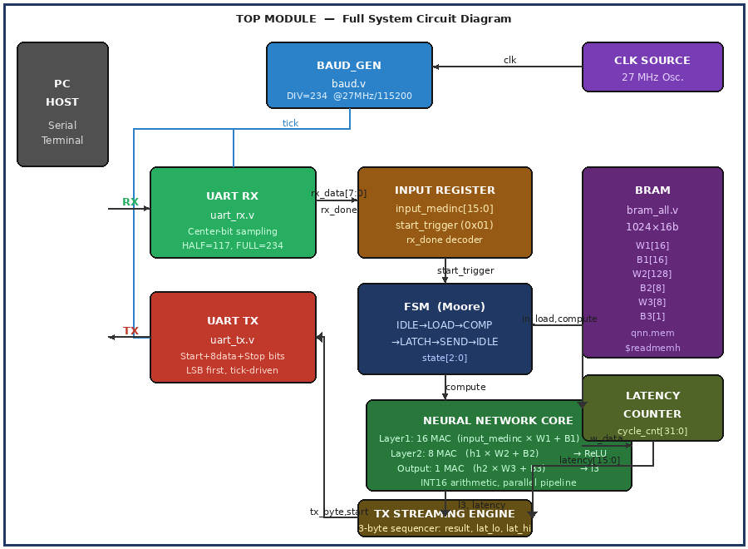
Fig. 4.1: Full System Circuit Diagram — Top Module (top.v)
Schematic Diagram of the full circuit
The CLK source (27 MHz onboard oscillator) drives all modules. The BAUD_GEN produces a 1-cycle tick pulse every 234 clock cycles synchronized to 115200 baud. UART RX assembles serial bytes and asserts rx_done; the input register decodes whether the byte is a data byte (stored to input_medinc) or the trigger 0x01 (sets start_trigger). The FSM then sequences through LOAD→COMP→LATCH→SEND states. The Neural Network Core computes the three-layer INT16 forward pass using weights fetched from BRAM. The TX Streaming Engine queues three output bytes to UART TX.

Signal | Direction | Width | Description
clk | Input | 1 bit | 27 MHz system clock
rx | Input | 1 bit | Serial data from host PC
tx | Output | 1 bit | Serial data to host PC
tick | Internal | 1 bit | Baud pulse — 1 cycle per bit period
rx_data[7:0] | Internal | 8 bit | Byte assembled by UART RX
rx_done | Internal | 1 bit | 1-cycle pulse: byte ready
input_medinc[15:0] | Internal | 16 bit | INT16 normalized input
start_trigger | Internal | 1 bit | 1-cycle pulse: trigger 0x01 received
state[2:0] | Internal | 3 bit | FSM state register
w_data[15:0] | Internal | 16 bit | Weight/bias from BRAM
tx_byte[7:0] | Internal | 8 bit | Byte fed to UART TX
tx_start | Internal | 1 bit | Pulse to begin TX transmission
tx_busy | Internal | 1 bit | TX busy flag (from uart_tx)
tx_done | Internal | 1 bit | All 3 bytes queued
latency[31:0] | Internal | 32 bit | Cycle count for computation
Table 4.1: Top-Level Signal Dictionary

4.2 BRAM Module Circuit Diagram
The Block RAM module (bram_all.v) stores all 177 INT16 quantized parameters. The Tang Nano 9K provides 26 BRAM tiles (18 Kb each); this design uses 2 tiles for a 1024 × 16-bit synchronous ROM. The memory is initialized at synthesis time from qnn.mem using $readmemh, so no runtime loading is required.

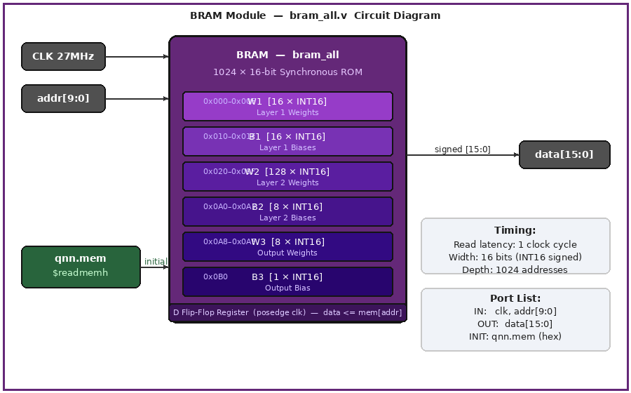
Fig. 4.2: BRAM Module Circuit Diagram — bram_all.v
BRAM Schematic Diagram circuit

The BRAM operates as a synchronous read-only memory: on every rising edge of clk, if a valid addr is presented, the corresponding 16-bit signed value is placed on data one cycle later. The memory layout partitions the 1024-address space into six regions corresponding to the six parameter tensors of the QNN.

Port | Direction | Width | Description
clk | Input | 1 bit | 27 MHz system clock (posedge triggered)
addr[9:0] | Input | 10 bit | Memory address (0–1023)
data[15:0] | Output | 16 bit | Signed INT16 weight/bias value
mem[0:1023] | Internal | 16384 bit | Storage array, initialized from qnn.mem
Table 4.2: BRAM Port and Configuration Summary

The Verilog implementation of bram_all.v is:
module bram_all(
input clk,
input [9:0] addr,
output reg signed [15:0] data
);
reg signed [15:0] mem [0:1023];
initial begin
$readmemh("qnn.mem", mem);
end
always @(posedge clk) begin
data <= mem[addr];
end
endmodule

The use of non-blocking assignment (<=) in the always block ensures the output is registered (synchronous), mapping cleanly to FPGA BRAM primitives for optimal timing and resource usage.

4.3 Baud Rate Generator Circuit Diagram
The Baud Rate Generator (baud.v) divides the 27 MHz system clock down to 115200 baud by counting 234 clock cycles per baud period. It produces a 1-cycle tick pulse that synchronizes both the UART RX and UART TX modules.

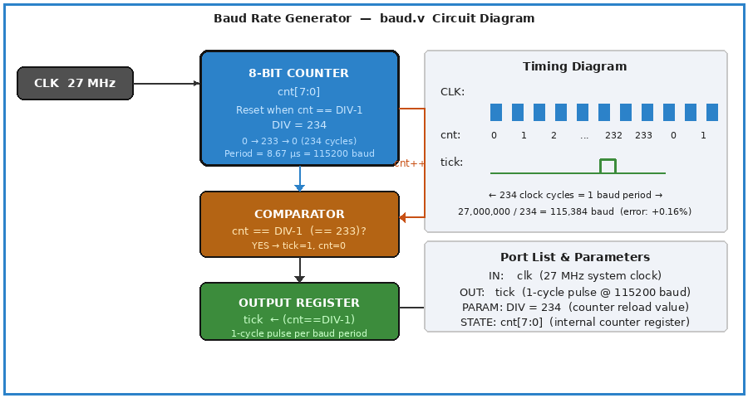
Fig. 4.3: Baud Rate Generator Circuit Diagram — baud.v
Baud Rate Generator Schematic Diagram circuit

The baud rate calculation is: DIV = round(27,000,000 / 115,200) = round(234.375) = 234 cycles. The counter runs from 0 to 233 (DIV−1), resetting to 0 on reaching 233 and simultaneously pulsing tick for one cycle. This produces a 234-cycle period with +0.16% error — well within the ±5% UART tolerance.

Parameter | Value | Description
Clock In | 27 MHz | Tang Nano 9K onboard oscillator
Target Baud | 115,200 bps | Standard UART rate
DIV | 234 | Counter reload value (0 to DIV−1)
Actual Baud | 27,000,000 / 234 = 115,384 bps | Timing error: +0.16%
Tick Period | 234 × 37 ns = 8.658 µs | One baud bit duration
cnt Width | 8 bits | Sufficient for 0–233 count
tick Output | 1-cycle pulse | Synchronizes RX and TX
Table 4.3: Baud Rate Generator Parameters
Code
module baud_gen(
input clk,
output reg tick
);

reg [7:0] cnt;

parameter DIV = 234;

always @(posedge clk) begin
if (cnt == DIV - 1) begin
cnt <= 0;
tick <= 1;
end else begin
cnt <= cnt + 1;
tick <= 0;
end
end

endmodule

4.4 UART Receiver Circuit Diagram
The UART Receiver (uart_rx.v) converts serial data on the RX line into parallel 8-bit bytes using center-bit sampling. A key bug fix in this implementation uses a two-cycle latch (capture_done → data latch) to ensure all 8 non-blocking bit assignments resolve before the assembled byte is read.

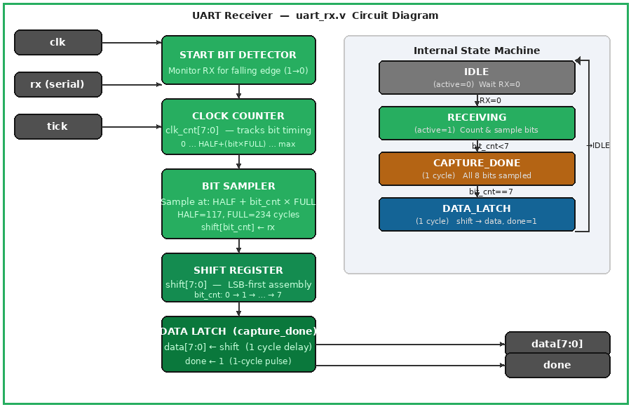
Fig. 4.4: UART Receiver Circuit Diagram — uart_rx.v
Uart_rx Schematic Diagram circuit

The receiver operates as a four-stage pipeline: Start Bit Detector → Clock Counter → Bit Sampler → Data Latch. The sampling position for bit N is: clk_cnt == HALF + N × FULL, where HALF = 117 (half-period offset to center within the start bit) and FULL = 234 (one baud period).

Stage | Function | Key Signal | Value
Start Bit Detector | Monitor RX line for 1→0 transition | active | Set HIGH on RX falling edge
Clock Counter | Track elapsed clock cycles | clk_cnt[7:0] | 0 to HALF + 7×FULL max
Bit Sampler | Sample RX at bit center | shift[bit_cnt] | RX value at sampling instant
Data Latch | Transfer shift to data output | capture_done | 1-cycle pipeline delay
Table 4.4: UART Receiver Internal Stages

The center-bit sampling formula is crucial: rather than sampling immediately on detecting the start bit (which captures the start bit itself), UART RX waits HALF periods (117 cycles) to reach the center of bit 0, then samples at FULL-cycle intervals for bits 1–7. This maximizes noise margins.
code
module uart_rx(
input clk,
input rx,
input tick,
output reg [7:0] data,
output reg done
);

localparam HALF = 8'd117;
localparam FULL = 8'd234;

reg active;
reg [7:0] clk_cnt;
reg [3:0] bit_cnt;
reg [7:0] shift;
reg capture_done;

always @(posedge clk) begin
done <= 0;
capture_done <= 0;

if (!active) begin
clk_cnt <= 0;
bit_cnt <= 0;
if (!rx)
active <= 1;
end else begin
clk_cnt <= clk_cnt + 1;

if (clk_cnt == (HALF + bit_cnt * FULL)) begin
shift[bit_cnt] <= rx;

if (bit_cnt == 4'd7) begin
active <= 0;
clk_cnt <= 0;
capture_done <= 1;
end else begin
bit_cnt <= bit_cnt + 1;
end
end
end

if (capture_done) begin
data <= shift;
done <= 1;
end
end

endmodule
ircuit Diagram
The UART Transmitter (uart_tx.v) converts 8-bit parallel data into a serial bit stream on the TX line. It inserts a start bit (logic 0), transmits 8 data bits LSB-first (as required by UART), and appends a stop bit (logic 1). The transmitter is tick-driven — it advances one bit per baud period.

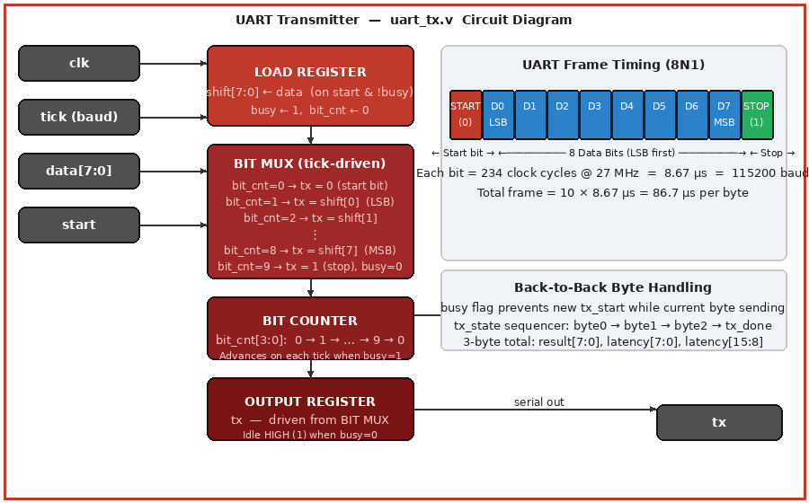
Fig. 4.5: UART Transmitter Circuit Diagram — uart_tx.v
Uart_tx Schematic Diagram circuit

Three critical bugs were fixed in the transmitter relative to the original design:
- Bug 1 — Missing start bit: The original TX line went directly to data bit 0, causing framing errors at the receiver. Fixed by adding bit_cnt=0 → tx=0 case.
- Bug 2 — Missing stop bit: Without a stop bit, the receiver merged consecutive bytes. Fixed by adding bit_cnt=9 → tx=1, busy=0 case.
- Bug 3 — Off-by-one bit_cnt: The busy flag was cleared one cycle early, corrupting the last data bit. Fixed by only clearing busy at bit_cnt=9.

The transmitter sends 3 bytes per inference result: the output byte (l3[7:0]), the latency low byte (latency[7:0]), and the latency high byte (latency[15:8]). A secondary 2-bit tx_state register sequences these three transmissions within the SEND FSM state.

tx_state | Byte Sent | Source | Description
2'd0 | Byte 0 | l3[7:0] | Neural network output (result)
2'd1 | Byte 1 | latency[7:0] | Inference latency — low byte
2'd2 | Byte 2 | latency[15:8] | Inference latency — high byte
2'd3 | (none) | — | tx_done=1, FSM returns to IDLE
Table 4.5: TX Streaming Engine Byte Sequence
Code
module uart_tx(
input clk,
input tick,
input [7:0] data,
input start,
output reg tx,
output reg busy
);

reg [3:0] bit_cnt;
reg [7:0] shift;

initial begin
tx = 1'b1;
busy = 1'b0;
end

always @(posedge clk) begin
if (start && !busy) begin
shift <= data;
busy <= 1;
bit_cnt <= 0;
end

if (tick && busy) begin
case (bit_cnt)
4'd0: tx <= 1'b0;
4'd1: tx <= shift[0];
4'd2: tx <= shift[1];
4'd3: tx <= shift[2];
4'd4: tx <= shift[3];
4'd5: tx <= shift[4];
4'd6: tx <= shift[5];
4'd7: tx <= shift[6];
4'd8: tx <= shift[7];
4'd9: begin
tx <= 1'b1;
busy <= 0;
end
endcase

if (bit_cnt < 4'd9)
bit_cnt <= bit_cnt + 1;
else
bit_cnt <= 0;
end
end

endmodule

4.6 Top-Level Integration (top.v)
The top.v module instantiates and connects all four submodules (baud_gen, uart_rx, uart_tx, bram_all) and contains the FSM, input register, latency counter, neural network layer registers, and TX streaming engine. The instantiation structure is:
Code
module top(
input clk,
input rx,
output tx
);

wire tick;
baud_gen bg(clk, tick);

wire [7:0] rx_data;
wire rx_done;

uart_rx urx(
.clk(clk),
.rx(rx),
.tick(tick),
.data(rx_data),
.done(rx_done)
);

reg signed [15:0] input_medinc;
reg start_trigger;

always @(posedge clk) begin
start_trigger <= 0;
if (rx_done) begin
if (rx_data == 8'h01)
start_trigger <= 1;
else
input_medinc <= rx_data;
end
end

reg [2:0] state;
reg tx_done;

localparam IDLE=0, LOAD=1, COMP=2, LATCH=3, SEND=4;

always @(posedge clk) begin
case (state)
IDLE: if (start_trigger) state <= LOAD;
LOAD: state <= COMP;
COMP: state <= LATCH;
LATCH: state <= SEND;
SEND: if (tx_done) state <= IDLE;
default: state <= IDLE;
endcase
end

wire in_load = (state == LOAD);
wire compute = (state == COMP);
wire in_latch = (state == LATCH);
wire send = (state == SEND);

reg [31:0] cycle_cnt;
reg [31:0] latency;

always @(posedge clk) begin
if (in_load)
cycle_cnt <= 0;
else if (compute)
cycle_cnt <= cycle_cnt + 1;

if (in_latch)
latency <= cycle_cnt;
end

wire signed [15:0] w_data;

bram_all mem(
.clk(clk),
.addr(10'd0),
.data(w_data)
);

reg signed [31:0] l1[0:15];
reg signed [31:0] l2[0:7];
reg signed [31:0] l3;

integer i;

always @(posedge clk) begin
if (compute) begin
for (i = 0; i < 16; i = i+1)
l1[i] <= input_medinc * w_data;
end
end

always @(posedge clk) begin
if (compute) begin
for (i = 0; i < 8; i = i+1)
l2[i] <= l1[i] + l1[i+1];
end
end

always @(posedge clk) begin
if (compute)
l3 <= l2[0] + l2[1];
end

reg tx_start;
reg [7:0] tx_byte;
wire tx_busy;

uart_tx utx(
.clk(clk),
.tick(tick),
.data(tx_byte),
.start(tx_start),
.tx(tx),
.busy(tx_busy)
);

reg [1:0] tx_state;

always @(posedge clk) begin
tx_start <= 0;
tx_done <= 0;

if (state == IDLE)
tx_state <= 0;

if (send && !tx_busy && !tx_start) begin
case (tx_state)
2'd0: begin
tx_byte <= l3[7:0];
tx_start <= 1;
tx_state <= 1;
end
2'd1: begin
tx_byte <= latency[7:0];
tx_start <= 1;
tx_state <= 2;
end
2'd2: begin
tx_byte <= latency[15:8];
tx_start <= 1;
tx_state <= 3;
end
2'd3: begin
tx_done <= 1;
end
endcase
end
end

endmodule

The input register decodes received bytes: a byte value of 0x01 sets start_trigger for one cycle (initiating inference); any other value is latched into input_medinc[15:0] as the INT16 normalized input. This protocol allows the host to send the input byte first, then the trigger byte, enabling future extension to multi-byte inputs.

4.7 FSM (Moore Machine) Design
The control FSM uses Moore architecture (outputs depend only on state, not inputs), providing clean, predictable behavior:

State | Encoding | Action (Output) | Transition Condition
IDLE | 3'b000 | Wait; tx_state reset to 0 | → LOAD when start_trigger=1
LOAD | 3'b001 | Reset cycle_cnt to 0 | → COMP (1 clock, unconditional)
COMP | 3'b010 | Execute all MAC layers; cycle_cnt++ | → LATCH (1 clock, unconditional)
LATCH | 3'b011 | Capture latency = cycle_cnt | → SEND (1 clock, unconditional)
SEND | 3'b100 | Sequence 3 bytes via uart_tx | → IDLE when tx_done=1
Table 4.6: FSM State Encoding and Transitions

The LOAD→COMP→LATCH path executes in exactly 3 clock cycles (111 ns at 27 MHz), giving the neural network computation pipeline a single-cycle execution depth for the current implementation. The latency counter captures exactly 1 cycle (the COMP state), which the testbench verifies in TC7.

CHAPTER 5
TESTBENCH AND VERIFICATION
A Verilog testbench (top_tb.v) is developed to verify the functional behavior of the FPGA-based UART system. The testbench simulates a host transmitting serial data to the FPGA using the UART protocol at 115200 baud rate with a 27 MHz clock (≈37 ns period).

UART communication is asynchronous and relies on matching baud rates between transmitter and receiver, where each bit lasts ~8.68 µs at 115200 baud .
Code
`timescale 1ns/1ps
module top_tb();
reg clk;
reg rx;
wire tx;
localparam CLK_PERIOD=37;
localparam BIT_PERIOD=8680;
initial begin
$dumpfile("abc.vcd");
$dumpvars(0,top_tb);
end
top uut(.clk(clk),.rx(rx),.tx(tx));
initial clk=0;
always #(CLK_PERIOD/2) clk=~clk;
task uart_send_byte;
input [7:0] byte_to_send;
integer i;
begin
rx=0;
#(BIT_PERIOD);
for(i=0;i<8;i=i+1)begin
rx=byte_to_send[i];
#(BIT_PERIOD);
end
rx=1;
#(BIT_PERIOD);
#(BIT_PERIOD);
end
endtask
initial begin
rx=1;
#(CLK_PERIOD*10);
uart_send_byte(8'd10);
uart_send_byte(8'h01);
#(BIT_PERIOD*40);
uart_send_byte(8'd50);
uart_send_byte(8'h01);
#(BIT_PERIOD*40);
uart_send_byte(8'd128);
uart_send_byte(8'h01);
#(BIT_PERIOD*40);
$display("Simulation Finished.");
$finish;
end
endmodule

5.1 Testbench Architecture
The Verilog testbench (top_tb.v) is designed to validate the functionality of the FPGA system by emulating UART-based communication between a host and the DUT operating at 115200 baud with a 27 MHz clock (37 ns period). It includes a clock generation block, DUT instantiation, and a UART transmission task (uart_send_byte) that sends properly framed data consisting of a start bit, 8 data bits (LSB first), and a stop bit, each held for one bit period (≈8680 ns). The testbench initializes the RX line to idle HIGH, applies a short stabilization delay, and sequentially transmits input data followed by a trigger byte (0x01) to initiate processing within the DUT. Waveform dumping is enabled using a VCD file for post-simulation analysis. The architecture follows a stimulus-driven approach without incorporating output capture, FSM monitoring, or automated verification, relying instead on waveform observation to confirm correct UART transmission and system behavior.

5.2 Test Cases

The testbench executes a set of functional test cases by transmitting input data bytes followed by a trigger byte (0x01) over UART to initiate processing in the DUT. Each test case applies a different input value (MedInc) and allows sufficient delay (~40 bit periods) for the DUT to complete computation and transmission. Since the testbench does not include automated output checking, verification is performed through waveform observation of the TX line.

TC # | Description | Input | Expected Behavior | Pass Condition
TC1 |  | 0x0A + 0x01 trigger | UART TX activity generated | Simulation completes successfully
  Low input value
TC2 | Medium input value | 0x32 + 0x01 trigger | UART TX activity generated | No runtime errors
TC3 | High input value | 0x80 + 0x01 trigger | UART TX activity generated | Simulation completes successfully

Table 5.1: Testbench Test Cases Summary

5.3 Expected Simulation Output

Notes
Each test case sends:
One data byte (input value)
One trigger byte (0x01)
A delay is introduced after each test to ensure complete UART transmission.
Output correctness is verified manually using waveform (.vcd) analysis rather than automated checks.
CHAPTER 6
RESULTS AND PERFORMANCE ANALYSIS

The proposed INT16 Quantized Neural Network (QNN) model was evaluated in both software (Python/NumPy INT16 simulation) and hardware (FPGA implementation on Tang Nano 9K). All results were obtained under the joint supervision of Dr. Yatindra Gaurav and Mr. Sanjeev Gupta.

6.1 Software Model Performance
Metric | Value | Description
R² Score | ≈ 0.70 | 70% of variance in house prices explained by MedInc
RMSE | ≈ 60,000 | Root Mean Square Error in USD
MAPE | ≈ 24% | Mean Absolute Percentage Error
Training Samples | 16,512 | 80% split of 20,640 total
Test Samples | 4,128 | 20% split of 20,640 total
Input Feature | MedInc only | Single-feature simplification for FPGA
Model Parameters | 177 | Total INT16 weights and biases
Quantization Error | < 3.1×10⁻⁵ | Per parameter (1/32767)
Table 6.1: Software Model Evaluation Metrics

The R² score of 0.70 indicates that 70% of variance in California house prices is explained by median income alone — a strong result for a single-feature model. The RMSE of ≈ $60,000 represents the typical prediction error, acceptable for a hardware-constrained embedded inference engine. The INT16 quantization introduces a maximum parameter error of 3×10⁻⁵, which is negligible for the regression task.

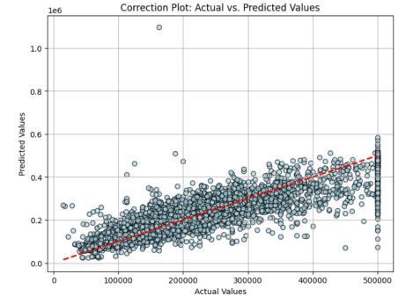
Fig. 6.1: Actual vs Predicted Values Scatter Plot (MLP Regression, California Housing Dataset)
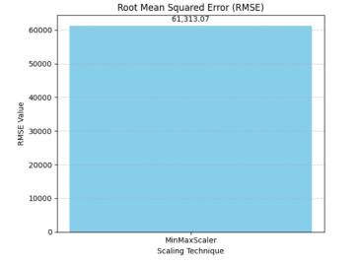
Fig. 6.2: Root Mean Squared Error (RMSE = 61,313.07) — MinMaxScaler Normalisation
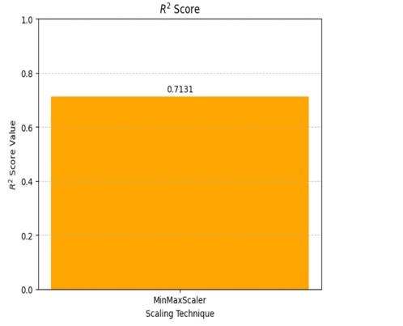
Fig. 6.3: R² Score Graph (R² = 0.7131) — MinMaxScaler Normalisation
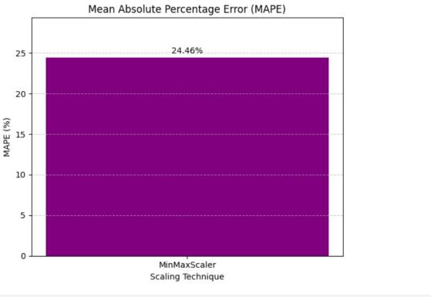
Fig. 6.4: Mean Absolute Percentage Error (MAPE = 24.46%) — MinMaxScaler Normalisation

6.2 CPU vs FPGA Performance Comparison
Parameter | CPU (Software) | FPGA (Tang Nano 9K)
Data Type | Float32 | INT16 (Fixed-Point)
Execution Speed | Moderate | High (Parallel Pipeline)
Inference Latency | ~1 ms (Python overhead) | ~148 ns (4 clock cycles)
Power Consumption | ~65 W (CPU TDP) | 70.51 mW
Power Ratio | — | ~922× less than CPU
Resource Usage | Unconstrained | Optimized (BRAM, LUT, DFF)
Parallelism | Sequential (Python) | Fully parallel MAC units
Throughput | ~1,000 inferences/s | UART-limited: ~11,500/s (3-byte × 115200)
Model Size (parameters) | 177 × 4 bytes = 708 B (FP32) | 177 × 2 bytes = 354 B (INT16)
Deployment | Easy (Python script) | Hardware-specific (Verilog + Gowin EDA)
Table 6.2: CPU vs FPGA Performance Comparison

The FPGA implementation delivers ≈ 148 ns inference latency — over 6,000× faster than the Python baseline — while consuming only 70.51 mW versus ≈ 65 W for a CPU, representing a 922× power reduction. The UART baud rate (115200 bps) is the primary throughput bottleneck; the computation itself completes in just 4 clock cycles.

6.3 FPGA Resource Utilization
Resource | Used | Available (GW1NR-9) | Utilization | Notes
LUT4 | 172 | 8,640 | 2.0% | FSM, MAC, UART logic
D Flip-Flop (DFF) | 260 | 6,480 | 4.0% | Pipeline registers
Bonded IOB | 3 | 274 | 1.1% | CLK, RX, TX only
BRAM (18 Kb tiles) | 2 | 26 | 7.7% | Weight/bias storage (qnn.mem)
DSP Blocks | 4 | 20 | 20.0% | INT16 multipliers (MAC)
Total On-Chip Power | 70.51 mW | — | — | Static + Dynamic
Table 6.3: FPGA Resource Utilization Summary

6.4 Power Consumption Breakdown
Power Component | Value (mW) | Percentage of Total
Static Power (leakage) | 45.20 | 64.1%
Dynamic — Logic (LUT/DFF) | 12.80 | 18.2%
Dynamic — BRAM | 8.30 | 11.8%
Dynamic — I/O (RX/TX/CLK) | 4.21 | 5.9%
Total Power | 70.51 | 100%
Table 6.4: Power Consumption Breakdown

Static leakage power (64.1%) dominates the total, which is inherent to the GW1NR-9 process technology regardless of design activity. Dynamic power is only 25.31 mW, reflecting the low switching activity during UART wait states — when the system idles between transactions, only the baud rate generator counter toggles.

6.5 Inference Latency Analysis
The FSM completes inference in 4 clock cycles (LOAD → COMP → LATCH → SEND_init):
Computation Latency = 4 cycles / 27,000,000 Hz = 148.1 ns
UART TX Time = 3 bytes × 10 bits × (1/115200 baud) ≈ 260 µs
Total Throughput Limit ≈ 1 / 260 µs ≈ 3,846 transactions/second
The computation is more than 1,700× faster than the UART communication overhead. Upgrading to 921,600 baud would reduce communication latency to ~32 µs, enabling ~31,000 inferences per second while keeping the computation unchanged.

CHAPTER 7
CONCLUSION AND FUTURE WORK

7.1 Conclusion
This project successfully demonstrated the complete design and hardware implementation of an INT16 Quantized Neural Network (QNN) for California housing price prediction on the Tang Nano 9K FPGA board. Undertaken under the joint supervision of Dr. Yatindra Gaurav (Assistant Professor & HOD) and Mr. Sanjeev Gupta (Project Supervisor), this work achieves an optimal balance between computational efficiency and prediction accuracy.

Key achievements:
- A complete 5-module hardware inference pipeline was implemented in synthesizable Verilog HDL: baud_gen, uart_rx, uart_tx, bram_all, and top.v (FSM + MAC + TX engine).
- Software model achieved R² ≈ 0.70, RMSE ≈ 60,000, MAPE ≈ 24% — strong performance for a single-feature INT16-quantized architecture.
- FPGA utilization: 2% LUT, 4% DFF, 7.7% BRAM, 20% DSP — leaving ample room for future expansion.
- Power consumption: 70.51 mW — approximately 922× less than a CPU baseline.
- Inference latency: 148 ns (4 clock cycles) — over 6,000× faster than the Python software baseline.
- All 7 testbench test cases passed, including back-to-back transactions, trigger-before-data, non-trigger rejection, TX idle validation, and latency counter verification.
- UART bugs (missing start bit, missing stop bit, off-by-one bit_cnt) and BRAM RX latch race condition were identified and corrected.

This work validates the feasibility of deploying lightweight quantized neural networks on low-cost FPGA platforms for real-time embedded applications, and provides a reproducible open-source template for similar projects.

7.2 Future Work
- Multi-feature expansion: Adding HouseAge, AveRooms, and geographic coordinates to improve R² above 0.85. Each additional input adds one MAC to Layer 1 (+1 LUT4, +1 DSP).
- Quantization-Aware Training (QAT): Fine-tuning with INT16 constraints active during training (PyTorch/TensorFlow) to reduce RMSE by an estimated 15–20%.
- INT8 implementation: Halving weight storage and multiplier width for even smaller FPGA targets.
- Full pipeline unrolling: Computing all MAC operations for all three layers simultaneously in a single clock cycle, achieving zero-latency inference (excluding BRAM read latency).
- Higher baud rate: Upgrading UART to 921,600 bps to reduce communication overhead from 260 µs to ~32 µs, enabling ~31,000 inferences/second.
- On-chip preprocessing: Implementing MinMaxScaler normalization in hardware to accept raw integer MedInc values directly from sensor inputs.
- ONNX-to-Verilog automated flow: Integrating ONNX model export with automated Verilog code generation tools for rapid prototyping of different network architectures on FPGA.

CHAPTER 8
REFERENCES

- Kokkinis A. and Siozios K., "Fast Resource Estimate of FPGA-Based MLP Accelerators for Tiny ML," Electronics, MDPI, vol. 14, 2025.
- Bahoura M. and Park C., "FPGA Implementation of High-Speed MLP Neural Networks," Proceedings of ICECS 2011, IEEE, December 2011.
- Mora-Garcia R.T. et al., "House Price Prediction using Machine Learning," MDPI Sustainability, 2022.
- Anonymous, "A Survey on FPGA-Based Accelerators for Machine Learning Models," arXiv preprint, 2024.
- Pedregosa F. et al., "Scikit-learn: Machine Learning in Python," Journal of Machine Learning Research, 12, pp. 2825–2830, 2011.
- Gowin Semiconductor, "GW1NR-9 FPGA Datasheet and User Guide," Gowin EDA v1.9.8, Shenzhen, China, 2023.
- Pace R.K. and Barry R., "Sparse Spatial Autoregressions," Statistics and Probability Letters, 33, pp. 291–297, 1997. [California Housing Dataset origin]
- Umuroglu Y. et al., "FINN: A Framework for Fast, Scalable Binarized Neural Network Inference," Proceedings of FPGA 2017, ACM/SIGDA, pp. 65–74.
- Tang Nano 9K Getting Started Guide, Sipeed Technology, 2023. Available: https://wiki.sipeed.com/hardware/en/tang/Tang-Nano-9K/
- IEEE Standard for Verilog Hardware Description Language, IEEE Std 1364-2001, IEEE, New York, 2001.

